**National University of Computer and Emerging Sciences**



**Lab Manual 03**

**Programming Fundamentals**

|  |  |
| --- | --- |
| Course Instructor | Dr. Aamir Wali |
| Lab Instructor (s) | Ms. Arfa  Ms. Hira |
| Section | BCS-1B |
| Semester | Fall 2022 |

Department of Computer Science

FAST-NU, Lahore, Pakistan

## **Objectives**

* The purpose of this lab is to familiarize you with the programming tool. Lo and behold! You will be working on the **Microsoft Visual Studio** through your journey to learn programming in this course. You will be able to understand how to make a project in visual studio, how the program is executed and what the sequence of the output is.
* Pseudo Codes (Loops)

**Task 1:**

Write a pseudo code using loops that prints the numbers from 1 to 100. You should also print the word ‘tea’ after every even number. Output will be 12tea34tea…….

**Task 2:**

Write a pseudo code using loops that takes a number N and print the N numbers of the

Following sequence: 1, 2, 4, 7, 11, 16, 22, 29… If N is 3, then print 1, 2, and 4.

**Task 3:**

Write a pseudo code that keep taking input numbers from user and terminate the program when user enters -1. Your task is to determine either user enter any number 3 time in a row or not.

**For example**

1. 4 5 1 6 3 1 2 1 -1

Return false

1. 5 4 3 1 3 4 1 6 6 6 4 3 1 -1

Return True as 6 entered 3 times in a row.

**Task 4:**

Write a pseudo code to display the cube of the number upto given an integer.

**Task 0: My First Computer Program**

**Creating a New Project**

It’s time to start! Go ahead and open up Visual Studio from the desktop or start menu.

When you create an app in Visual Studio, you first create a project and a solution. For this example, you’ll create a Windows console application.

* Create a project by pointing to **New** on the **File** menu, and then clicking **Project**.

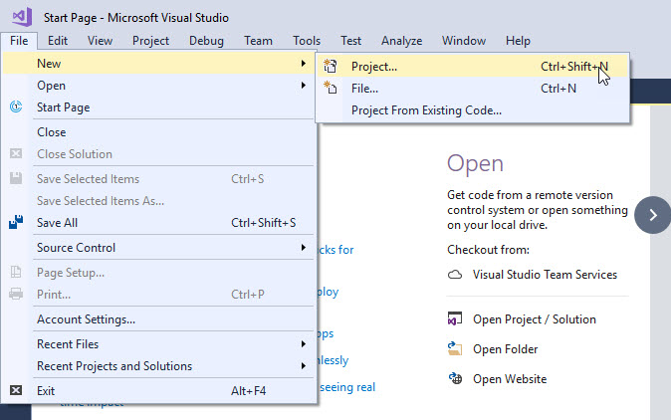

* In the **Visual C++** project types pane, click **Win32**, and then click **Win32 Console Application**.

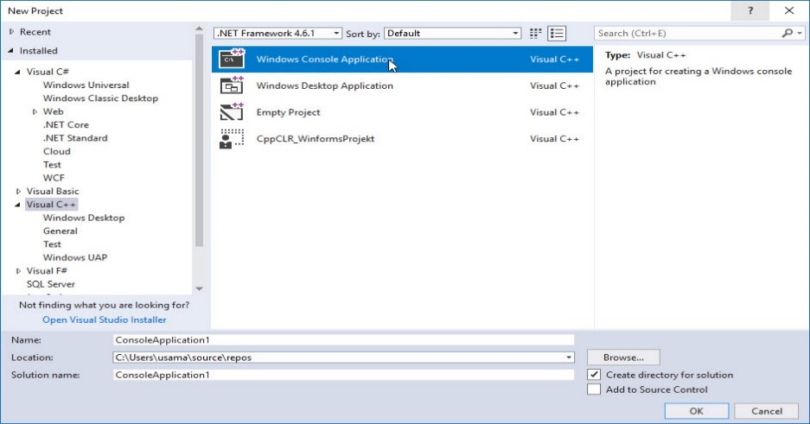

* Type a name for the project.

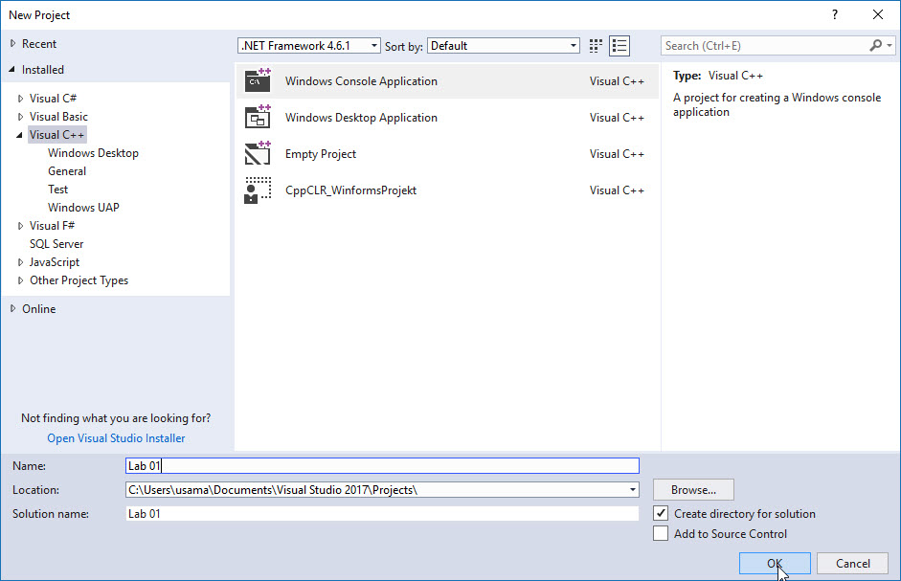

* By default, the solution that contains the project has the same name as the project, but you can type a different name. You can also type a different location for the project.
* Click **OK** to create the project.
* In the **Win32 Application Wizard**, click **Next**, select **Empty Project**, and then click **Finish**.

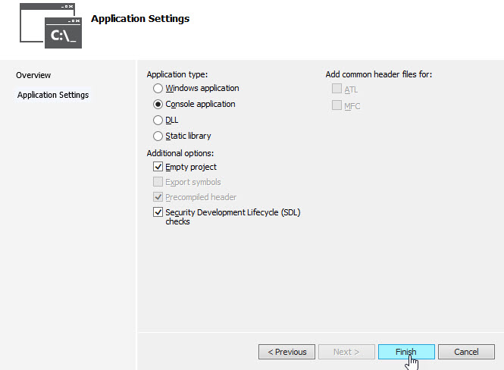

* If **Solution Explorer** is not displayed, on the **View** menu, click **Solution Explorer**.

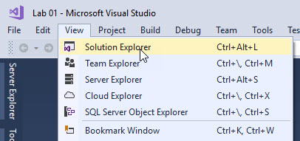

* Add a new source file to the project, as follows.
  + In **Solution Explorer**, right-click the **Source Files** folder, point to **Add**, and then click **New Item**.

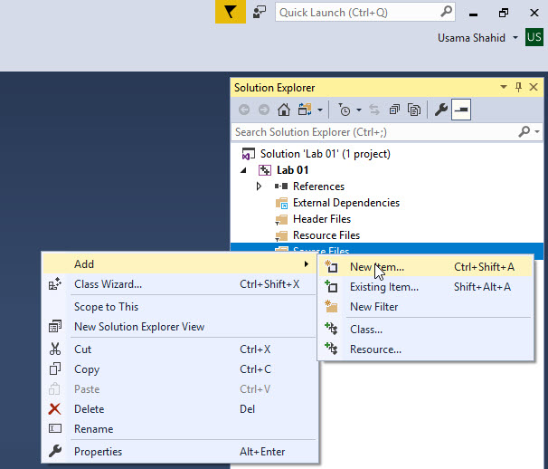

* + In the **Visual C++** node, click **C++ File (.cpp)**, type a name for the file, and then click **Add**.

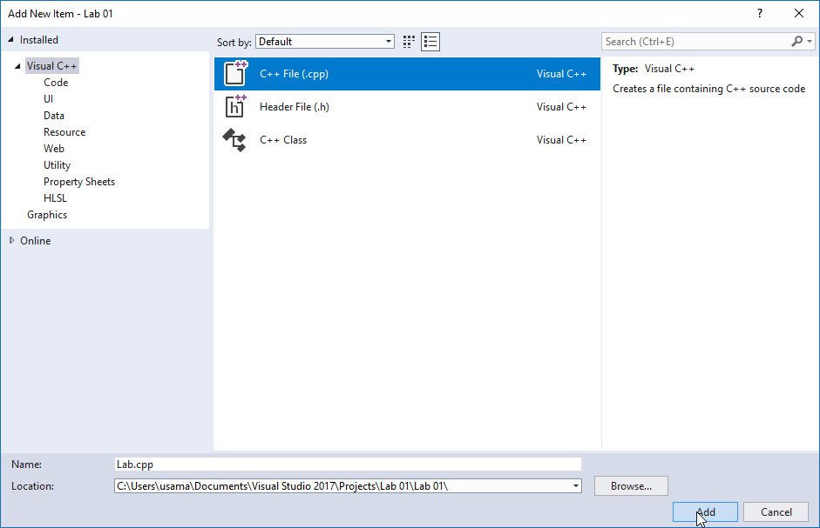

* The **.cpp** file appears in the Source Files folder in **Solution Explorer**, and the file is opened in the Visual Studio editor.
* In the file in the editor, type a valid C++ program.
* **Task 1:**

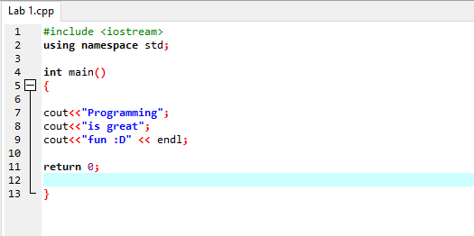

* Write the above code in the file in the editor.
* Compile the code and observe the program output.
* **Task 2:**

Write a c++ program to print **“Hello!! Welcome in the world of programming”** on console.

* **Task 3:**

Write a C++ program to print “your name, roll no., degree, section and lab Number” in the following format.

**\*\*\*\*\*\*\*\*\*\*\*\*\*\*\*\*\*\*\*\*\*\*\*\*\*\*\*\*\*\*\*\*\*\*\*\*\*\*\*\*\*\*\*\*\*\*\*\*\*\*\*\*\*\*\*\*\*\*\*\*\*\***

**Welcome to Programming Fundamentals**

**Name: Sonia Anum**

**Roll #: Mscs19044**

**Degree: MS (CS)**

**Section: A**

**Lab: 03**

**\*\*\*\*\*\*\*\*\*\*\*\*\*\*\*\*\*\*\*\*\*\*\*\*\*\*\*\*\*\*\*\*\*\*\*\*\*\*\*\*\*\*\*\*\*\*\*\*\*\*\*\*\*\*\*\*\*\*\*\*\*\*\*\***